****-+Australian Government
Australia's Economic Accelerator

# 2023-24 Annual Report on research translation and commercialisation

Australia’s Economic Accelerator (AEA) Advisory Board



With the exception of the Commonwealth Coat of Arms, the Department’s logo, any material protected by a trade mark and where otherwise noted all material presented in this document is provided under a [Creative Commons Attribution 4.0 International](https://creativecommons.org/licenses/by/4.0/) (https://creativecommons.org/licenses/by/4.0/) licence.

The details of the relevant licence conditions are available on the Creative Commons website (accessible using the links provided) as is the full legal code for the [CC BY 4.0 International](https://creativecommons.org/licenses/by/4.0/legalcode) (https://creativecommons.org/licenses/by/4.0/legalcode)

The document must be attributed as the (AEA Advisory Board 2023-24 Annual Report).

Contents

Acknowledgement of Country 2

Letter to the Minister for Education 3

Foreword from the Chair 4

What is the AEA? 5

The Board 6

Terms of appointment 6

Oversight 6

Board members 7

The Priority Managers 10

Australia’s research landscape 11

Key partnerships to inform policy 12

The Research Commercialisation Strategy 13

The Investment Plan 13

Additional achievements and outcomes 14

AEA Seed 16

Lessons learned from AEA Seed 18

Seed case studies 19

Renewables and Low Emissions 19

Medical Science 21

Current state of AEA 22

Related programs in Education portfolio 23

The Trailblazer Universities Program 23

Workforce initiatives 26

National Collaborative Research Infrastructure Strategy (NCRIS) 29

Conclusion 30

Appendices 31

Appendix A: Board member’s terms of appointment 31

## Acknowledgement of Country

The Department of Education acknowledges the Traditional Owners and Custodians of Country throughout Australia and their continuing connection to land, waters and community. We pay our respects to them and their cultures, and Elders past and present.

## Letter to the Minister for Education

Dear Minister

In accordance with Section 42-20 of the *Higher Education Support Act 2023*, I present the 2023-24 Annual Report on behalf of the members of the AEA Advisory Board. This report covers the activities of the Board under interim arrangements and the operations of the AEA in 2023-24.

Since the interim arrangements for the AEA Advisory Board (the Board) came into effect on 13 December 2023, the Board has developed its 5-year research commercialisation strategy and its annual investment plan for 2024-25.

The strategy outlines the vision, aims and the objectives of the Board for the AEA. The strategy identifies the regulatory, financial, and cultural barriers to commercialisation and proposes actions in which the program can address those barriers.

The AEA supports research translation and commercialisation that aligns with the Government identified priority areas of the economy (outlined in the *National Reconstruction Fund Corporation (Priority Areas) Declaration 2023*). To ensure AEA investment drives the best possible outcomes, the Board has identified focus areas of national priority to be prioritised for AEA funding. The Board’s annual investment plan is underpinned by a robust methodology and identifies 6 AEA focus areas for investment in areas of high commercial opportunity and research strength. These focus areas will guide AEA investment decisions. The approach taken by the Board backs in the Government’s Future Made in Australia policy – to build Australia’s resilience, sovereign capability and security by supporting research, development, translation and commercialisation of technologies in Australia.

For each focus area, the plan provides key data around research strength, research translation potential, market size, and strategic alignment with areas of national priority that have informed their selection. The research commercialisation strategy and the investment plan provide guidance and greater transparency to researchers and industry around AEA program direction and decisions.

The Board and the Department of Education have had rich discussions on the AEA with stakeholders across government, and with universities and researchers, investors, and industry that have informed our current approach. Our engagement with stakeholders will continue as the Board’s approach will need to evolve over time to maintain the currency and relevance of the AEA in the research ecosystem.

The AEA is one lever in that ecosystem that can increase research commercialisation and translation pathways. Over time, the impact of the AEA, the Trailblazer universities program and the Increase Workforce Mobility Initiative, along with complementary programs in other portfolios, will help shift the dial to increase translation and commercialisation of Australian research and enhance our sovereign capability.

I look forward to working with you over the next year delivering positive economic outcomes for all Australians.

Yours sincerely

**Mr Jeff Connolly**

Chair of the AEA Advisory Board

## Foreword from the Chair

As the inaugural Chair of the Australia’s Economic Accelerator Advisory Board, I am pleased to present the AEA Annual Report for 2023-24.

This Board is established under the *Higher Education Support Act 2003* (HESA) to provide advice to the Minister for Education in relation to the broader translation and commercialisation of university research agenda and on the AEA’s objectives, conditions of eligibility and conditions of grants.

The AEA is a priority-driven national program that aligns with the Government’s Future Made in Australia policy and within the framework established through the Government identified priority areas for the economy (outlined in the *National Reconstruction Fund Corporation (Priority Areas) Declaration 2023*). The AEA operates alongside the Trailblazer Universities, Increase Workforce Mobility Initiative, and the CSIRO ON program and Main Sequence Ventures. The AEA complements other programs such as the National Reconstruction Fund Corporation, the Industry Growth program in the Industry portfolio, and the Advanced Strategic Capabilities Accelerator in the Defence portfolio. Together, these programs provide incentives for university researchers, industry partners and investors to work together to unleash the real-world impact of the excellent research in Australian universities.

Along with these programs, the Government’s strategic examination of Australian research and development will be another important element in extracting more economic benefit from the public investment into university research.

The Board’s first Annual Report provides an overview of the activities and program of the Board in the first year of operation.

The Board, the Department of Education and the priority managers will continue to work with university researchers, industry and end-users of research, and investors to identify those areas where they can partner on research which addresses the Government’s Future Made in Australia agenda and the Government identified priority areas for the economy (outlined in the *National Reconstruction Fund Corporation (Priority Areas) Declaration 2023*).

It has been an honour to chair the AEA Advisory Board – a group of wholly dedicated individuals, each with their own wealth of skills, experience and expertise in the university research, science translation and commercial arenas.

I want to thank each Board member for bringing the full weight of their knowledge and experience to the challenge of advising Government on research innovation and translation. I would also like to thank the secretariat in the Department of Education for their professionalism and support of the Board.

**Mr Jeff Connolly**

Chair

AEA Advisory Board

#### What is the AEA?

AEA is a $1.6 billion program dedicated to funding translation and commercialisation in the Government identified priority areas of the economy (outlined in the *National Reconstruction Fund Corporation (Priority Areas) Declaration 2023*).[1] These are:

* value-add in resources
* agriculture, forestry & fisheries
* medical science
* renewables & low emission tech
* defence capability
* transport
* enabling capabilities.

AEA will help bridge the ‘valley of death’ and accelerate reform in the higher education sector for translation and commercialisation research capacity through targeted investment in priority areas.

AEA operates a fast-fail model designed to rapidly de-risk projects that have high commercialisation potential at a proof-of-concept or proof-of-scale level of commercial readiness. The AEA Advisory Board oversees the delivery of the program. The Board is comprised of 8 members, who possess experience and knowledge in research and its commercialisation, and represent government, industry business and research sectors.

Priority managers support the Board and are highly qualified, experienced and motivated business and technology specialists.

The AEA Advisory Board will oversee the priority managers and advise the Minister for Education on the commercialisation of research through a Research Commercialisation Strategy which is to be developed every 5 years from 2022–23.

AEA will drive commercial research outcomes in universities through a fundamentally new approach to research funding.

#### The Board

Interim arrangements for the Board were in place from 13 December 2023 to 12 June 2024. Following an executive recruitment exercise for the longer-term arrangements for the Board in April 2024, the AEA Advisory Board was appointed by the Minister for Education, the Hon Jason Clare MP, on 3 July 2024.

### Terms of appointment

The AEA Advisory Board is a statutory advisory body established under Subdivision 42-B of HESA.

Section 42-15 of HESA sets out the functions of the Board:

1. to advise the Minister in relation to translation and commercialisation of university research
2. to advise the Minister in relation to the Australia’s Economic Accelerator program, including in relation to objectives, conditions of eligibility and conditions of grants
3. to oversee the performance of functions by priority managers engaged under section 42-75
4. any other functions conferred on the AEA Advisory Board by this Act or the Other Grants Guidelines
5. to do anything incidental or conducive to the performance of the above functions.

In carrying out its role, the Board helps the AEA pilot program to:

1. support higher education providers to bridge the divide between basic research activities and commercialisation outcomes, through closer engagement with industry partners
2. support research activities aligned to priority areas, undertaken by higher education providers
3. boost the research capability of higher education providers to conduct research with high commercialisation potential
4. foster a culture of collaboration between universities and industry
5. encourage industry engagement with university research, boosting research capability in areas with the greatest potential for economic impact.

Section 42-25 of HESA stipulates that the Board must consist of the following members who are to be appointed by the Minister:

1. the Chair
2. the Deputy Chair
3. not fewer than 4, and not more than 6, other members.

### Oversight

The Board has direct oversight of AEA and advises the Minister for Education in relation to the objectives, conditions of eligibility and conditions of grant of this program. In addition, the Board advises the Minister for Education on the translation and commercialisation of university research more generally and therefore, is well positioned to provide strategic advice related to the delivery of Trailblazer Universities Program and Increase Workforce Mobility Initiative. The Board does not have any decision‑making role in relation to these programs.

### Board members

Jeff Connolly has been appointed Chair of the AEA Advisory Board. He brings a wealth of experience in research translation and commercialisation related to the Government’s priority areas.

**Mr Jeff Connolly**

Chair



Jeff serves as Executive Director and CEO of Thales Australia, a premier provider of products, systems, solutions and services in the global defence, security, space, aerospace and civil digitalisation markets. Jeff also has a background as the Executive Chairman and CEO of Siemens Australia and New Zealand. He is known for his leadership in advancing the uptake of automation and digitalisation technologies applied to Australian infrastructure, manufacturing and process industries.  He chaired both the Australian Government’s Industry 4.0 taskforce and the University Research Commercialisation Scheme expert panel. Jeff was also an advisor to New South Wales Government’s Industry Policy White Paper.



**Ms Julia Spicer OAM**

Member

Julia Spicer OAM, has been appointed as Deputy Chair of the AEA Advisory Board.

Julia brings a regional and small business perspective to her experience in research commercialisation and innovation. As Queensland Chief Entrepreneur, she dedicated herself to facilitating opportunities for regional Australia. A University of Queensland graduate with a background in environmental management, Julia is an active leader and mentor, contributing to various roles such as chairperson for Global Entrepreneurship Network Australia and director of The Goondiwindi Business Hub. She is passionate about community and industry growth, in support of the sustainability of regional Australia.



**Dr Angeline Achariya**

Member

Member

Dr Angeline Achariya is a global leader in commercialising innovations in Agribusiness industries and currently leads as the CEO of Innovation GameChangers. Within her portfolio, Angeline is the Asia Pacific Chair of Food Systems Innovation & Resilience, G100 Mission Million. She holds board director roles with Nutrition and Catering Institute, Australian Food Science & Technology Institute, and senior advisor at Beanstalk Agtech. Angeline brings over 25 years’ experience in multinational giants such as J R Simplot, Mondelez International, Yum Brands, Fonterra, Mars Corporation and Monash University. As a member of the AEA Advisory Board, Angeline brings expansive knowledge in agriculture and food innovation with skills in research translation and commercialisation.

Professor Mark Hutchinson, Director of the Australian Research Council (ARC) Centre of Excellence for Nanoscale BioPhotonics, is a globally recognised medical scientist with a focus on neuroimmune research. Leading the foundation of numerous startups, he has received prestigious awards for his outstanding contributions. With a strong academic background from the University of Adelaide, Mark's expertise extends to roles such as ARC Future Fellow, Chair of the Steering Committee for the Australian Pain Solutions Research Alliance, and Associate Editor of Brain, Behaviour and Immunity. Mark brings a wealth of expertise in research commercialisation and innovation within the fields of medical science, agriculture, defence and enabling capabilities

**Prof Mark Hutchinson**

Member



**Dr Paul Kelly**

Member



Dr Paul Kelly, an Australian physician and biotechnology entrepreneur, brings over 30 years of experience in developing and commercialising biomedical innovations in Europe, US and Australia. Prior to co-founding Sydney based Venture Capital Firm, OneVentures in 2010, Paul led numerous successful ventures in the US including Gemini Genomics, Agamatrix and Atomera. As founding partner at OneVentures he leads the Healthcare investment team. Paul holds medical and Doctorate degrees from the University of New South Wales. His distinguished career in endocrinology at St Vincent's Hospital, Sydney has led to serving on the boards of Garvan Institute of Medical Research, BiVacor, Prota Therapeutics, Clinical Genomics, Vaxxas, and Hatchtech. Paul brings a breadth of seasoned expertise in medical science and enabling capabilities with skills in investment and research translation and commercialisation.

Dr Virginia Marshall is a Wiradjiri Nyemba woman and a Research Fellow at the Australian National University's School of Regulation and Global Governance (RegNet). She is a practising lawyer and leading legal scholar with expertise in Aboriginal water rights, native title rights in Sea Country, Indigenous governance, and the intersection of Traditional Knowledge systems and western intellectual property regimes, especially in relation to traditional medicine research and development, and is Lead Chief Investigator on the Australian Research Council Discovery research project, Barriers and pathways to development of Indigenous traditional medicines. Virginia holds various government appointments, serving on the Climate Change Authority Board, Acting Chair of the Australian Government Department of Climate Change, Environment and Water’s Committee on Aboriginal Water Interests (CAWI) and on the Drafting Group for the National Water Initiative Mark 2.



**Dr Virgina Marshall**

Member

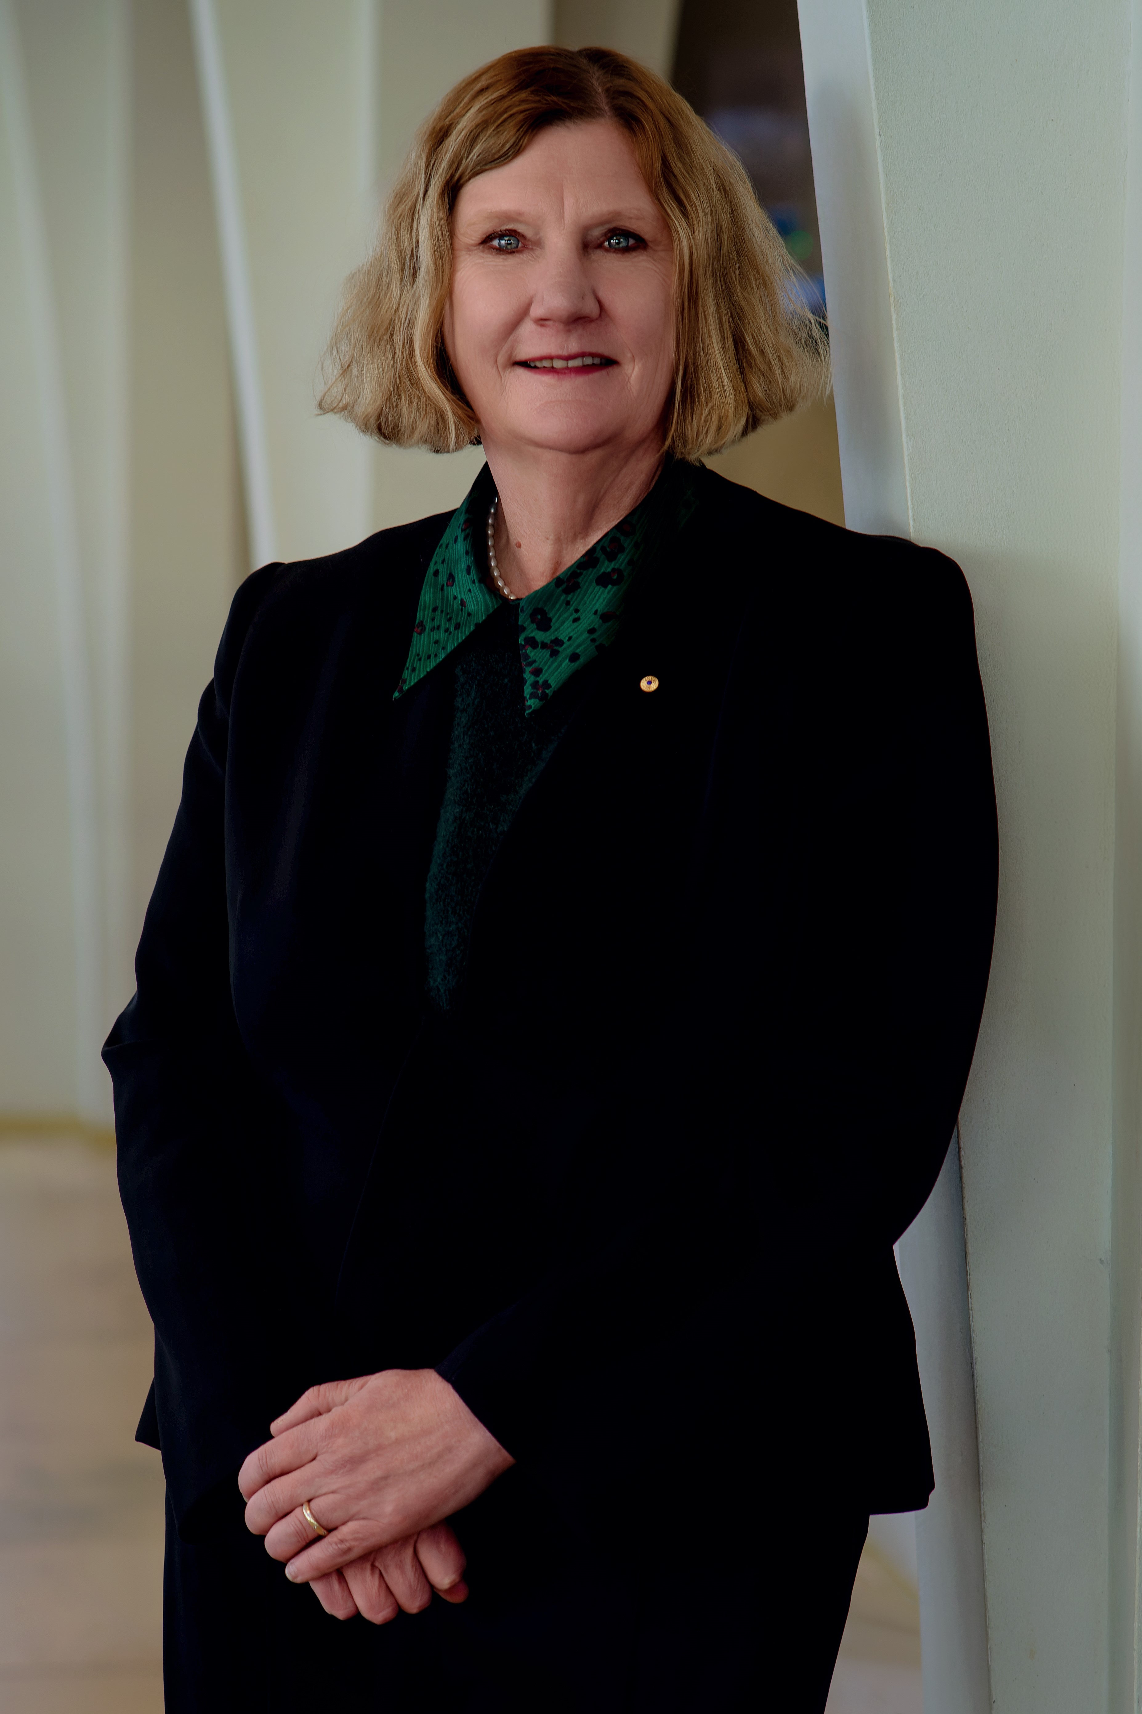As member of the AEA Advisory Board, Air Vice-Marshal (retired) Catherine (Cath) Roberts AO CSC has dedicated her career to innovation and stretching boundaries. She was Australia’s first Space Commander (2021-2023) and brings over 40 years of experience serving in the Royal Australian Air Force as an Aerospace Engineer. Cath has a passion for diversity in STEM through her work with Women in Aviation/Aerospace Australia, Women in Aviation International and has mentored in both the Future Through Collaboration (defence and industry) and Superstars of STEM programs. She is a Fellow of Engineers Australia, Member of Australian Institute of Company Directors, member of Defence SA Advisory Board and was a member of the Australian Space Agency Advisory Board from 2019-2023. In recognition of her achievements, Cath was awarded a Conspicuous Service Cross for her contribution to Aviation Safety in 2004 and appointed an Officer of the Order of Australia in 2022 for her service as Head Aerospace Systems Division and Head of Air Force Capability.

**Ms Catherine Roberts AO CSC**

Member

Member



**Ms Lauren Stafford**

Member

As a member of the AEA Advisory Board, Lauren Stafford is a skilled practitioner in commercialisation and intangible asset strategy including human capital, data and intellectual property. She has 15-years' experience in technology development and commercialisation in the resources sector. Lauren is currently the Director of Business Development at First Mode and formerly held leadership roles at Woodside Energy, BHP, Austmine and the University of Queensland. Lauren is a member of the Board of Industry Innovation and Science Australia and a member of the Research Infrastructure Advisory Board. Lauren brings strong commercialisation expertise and industry knowledge.

### The Priority Managers

The Board is supported by a lead priority manager, in addition to a team of priority managers who provide specialist technical advice. Priority managers act as conduits for university applicants, industry and potential end-users of research, and investors. Priority managers bring lived experience in innovation and research translation and commercialisation across the Government identified priority areas for the economy (outlined in the *National Reconstruction Fund Corporation (Priority Areas) Declaration 2023*).

In the pilot phase, priority managers were essential in raising awareness of AEA with universities. Priority managers worked closely with university research offices and technology transfer offices. They provided advice to potential applicants and assessed applications against program criteria.

AEA priority managers have a duty of care and diligence to act honestly and ethnically, in good faith, and to behave with integrity and discretion in the execution of their duties. As part of their role, priority managers disclose, and take reasonable steps to avoid, conflicts of interest in connection with their role.

Through their work with universities, industry and investors, priority managers will play a central role in identifying investment opportunities for AEA. To do this, priority managers will work with industry and universities to identify partnership opportunities for potential AEA projects.

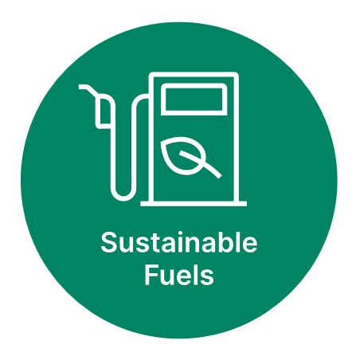The Board has considered the following focus areas where AEA can contribute to building sovereign capability and diversifying Australia’s economy:

## Australia’s research landscape

Australia contributed 3.42% of the world’s published research in 2022,[2] while representing only 0.33% of the world’s population.[3] Over 84% of Australian research is rated at or above world standard. Our research strength is demonstrated in numerous areas including technology, medicine and health sciences, and mathematical sciences where over 90% of research in these fields are rated at or above world standard.[4]

However, there is more scope to translate and commercialise more of Australia’s research into new products. Most of the innovation introduced by Australian businesses reflects incremental innovation, or a low degree of novelty or complexity. According to Organisation for Economic Co‑operation and Development (OECD) data, only around 14% of ‘product innovative’ firms in Australia introduced new-to-market innovations in 2018–20, placing us 23rd among the OECD countries (Table 1).[5]

According to the Atlas of Economic Complexity, while Australia ranks as the 9th richest economy per capita out of the 133 countries studied, Australia is the lowest ranked OECD country in terms of economic complexity, ranked 93rd between Uganda and Pakistan.[6] The Atlas of Economic Complexity ranks countries according to their ability to manufacture and export diverse and complex products and services.

**Table 1. OECD ranking, new to market innovations**

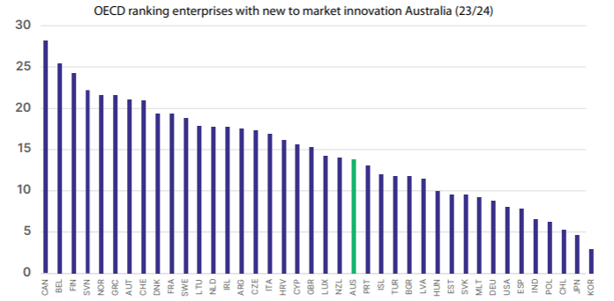

Source: OECD (2023), Business innovation statistics and indicators https://www.oecd.org/innovation/inno/inno-stats.htm

The Australian Innovation System Monitor ranks Australia last in the OECD for business collaboration on innovation with higher education or government institutions, noting ‘this reflects unfavourably on the ability of Australian businesses and research institutions to maximise the return on public investment in science and research.[7] Internal perceptions of university–industry collaborations within Australia are similarly low, ranking 40th on industry–university collaboration within the country in the World Economic Forum’s Global Competitive Index.[8]

Industry–university collaboration is key for the translation and commercialisation of research. Notwithstanding the high potential returns, metrics on the extent of collaboration indicate that Australia needs to improve its performance in industry–university collaboration if we want better commercial outcomes.

To help boost translation and commercialisation, over the 4 years to 2026-27, the Government will invest around $16.1 billion in research and development in the Education portfolio, including through Australia’s Economic Accelerator, the Trailblazer Universities Program, Research Block Grant~~s~~ allocations to higher education institutions, and through the Australian Research Council.

According to forecasted figures from the Science, Research and Innovation budget tables of the Department of Industry, Science and Resources, Australia’s investment into R&D will exceed $12.6 billion in 2023-24, an increase of $328 million (a 2.7% increase) from R&D investment in 2022‑23 and a $2.4 billion increase in government investment into R&D from 5 years ago in 2019-20 (a 23.5% increase).[9] The Education portfolio is a major contributor to this investment into Australia’s research sector, allocating over $3.9 billion into R&D activities in 2023-24 (30.9% of total Government R&D investment).

### Key partnerships to inform policy

To complement its research and analytical work to inform AEA and other research commercialisation programs, the department has entered into strategic partnerships with the Australian Academy of Technological Sciences and Engineering (ATSE) and Knowledge Commercialisation Australasia Limited (KCA). The outputs of this work are part of a broader suite of data, research and information sources utilised to inform this ongoing implementation effort, including the department’s own data collections, information collected by other government agencies and consultation across Government, industry and the research sector.

The ATSE partnership is aimed at identifying areas of R&D strength in Australia and opportunities for translation and commercialisation in these areas. This work has included assessments of technology readiness across the infrastructure, regulatory, and market dimensions, skills availability, and global competitiveness. ATSE has drawn on the expertise of their membership of around 900 Fellows across industry and academia spanning the fields of applied science, technology, and engineering to inform these reports. The department and the Board will use project outputs to identify investment priorities for the AEA.

The partnership with KCA is aimed at enhancing the quality and comprehensiveness of the Survey of Commercialisation Outcomes from Public Research (SCOPR). SCOPR is an annual survey that collects data on research commercialisation activities such as research and commercialisation income, commercialisation staff, and patents by universities and public research organisations in Australia and New Zealand. SCOPR is currently the only information source in Australia for many of these metrics. The data collected through SCOPR is helpful in understanding and measuring university research commercialisation activities and outcomes.

### The Research Commercialisation Strategy

Under Section 42-1 of HESA, the Board is required by legislation to develop a 5-year research commercialisation strategy. The strategy outlines the vision of AEA – to foster a culture of collaboration between universities and industry, catalysing public and private investment in the translation and commercialisation of research, increasing Australia’s sovereign capability, and creating a stronger and more complex Australian economy.

To meet the legislated requirement that the strategy is not inconsistent with Australia’s greenhouse gas emissions reduction targets, the Board will stipulate that at least one of the technology focus areas encourages applications designed to assist with the transition to the Australian Government’s legislated target of net zero by 2050.

The strategy also sets out how the Board will adapt their commercialisation focus areas as national priorities evolve over time.

Finally, the strategy outlines the Board’s direction on how AEA will address the financial, cultural and regulatory barriers to commercialisation.

### The Investment Plan

As required under Section 42-5 of HESA, the Board must, in relation to each year, formulate written policies for the AEA program, dealing with the following matters in relation to the year:

1. areas of national priority;
2. the total amount of funding available;
3. any other matters the AEA Advisory Board considers appropriate to deal with to ensure the program meets the program’s objectives.

The Board has released its first investment plan for 2024-25. The plan states the amount of available AEA funding, the areas of national priority and focus areas that are highlighted for investment in the first rounds.

The annual investment plan exercise ensures AEA remains agile and responsive to developments in the research and industry sectors and provides for transparency on the program’s direction.

Innovate grants support proof of scale projects at TRL 5-7, with grants of up to $5 million over 24 months. Innovate projects must have co-investment from industry partners to demonstrate their commercial viability.

The 2024-25 investment plan, which was published to support the opening of AEA funding rounds, provides data for each area around research strength, research translation potential, market size, and strategic alignment with areas of national priority that have informed their selection.

The inclusion of 6 specific AEA focus areas in the 2024–25 AEA investment plan will guide investment decisions and support the policy intention of the Government’s Future Made in Australia agenda. This will target the Government’s investment in research commercialisation towards areas where Australia has economic advantages.

### Achievements and outcomes

1. **National priority areas**

Working with the framework of the Government identified priority areas for the economy (outlined in the *National Reconstruction Fund Corporation (Priority Areas) Declaration 2023*), the Board has considered a range of data, analytical and policy information to refine focus areas that:

* consider significant future market opportunity
* play to Australia’s research and other strengths, including our natural resources,
* focus on where there is potential to improve Australia’s performance in translating research
* align with current national economic and policy objectives
* the Board has considered analysis of market opportunities from a domestic and global perspective and Australia’s strengths in critical technology areas.

The Board’s work is informed by policy scans across government which identify focus areas aligned with the Government’s identified priority areas. There is significant alignment between the focus areas and current Government strategies to improve Australia’s sovereign capability and where there is a need for investment to meet industry demand and secure market opportunities. Improving research translation outcomes in these areas has the potential to build stronger domestic industries and support Australia to play a greater role in key global supply chains.

Additional work is being undertaken to develop tangible industry problem statements to focus the work of researchers, drawing on industry and expert input.

1. **University-industry engagement**

A targeted engagement plan will underpin and drive a behavioural shift towards ‘collaborate to commercialise’ between Australian universities and industry. The objectives of the engagement plan include:

* increasing awareness of available programs within key groups that facilitate the commercialisation of research
* enhancing recognition of Australian university research to foster commercialisation connections with industry partners
* promotion of positive examples of university and industry partnership on research commercialisation opportunities.

The Board’s engagement plan will identify targeted opportunities to promote research commercialisation programs with stakeholder groups (individual researchers, First Nations Australians, universities, peak bodies, industry, investors and end-users of research) and encourage greater participation in the AEA. This will help build capacity with these key stakeholders, particularly amongst equity groups.

The AEA website was launched on 15 December 2023.[10] Having an AEA branded channel promotes the program and is used to announce grant rounds and recipients. It is also used to promote other research translation and commercialisation programs and initiatives across the ecosystem (including, but not limited, to the Trailblazer Universities Program, National Industry PhD program, Industry Growth Program, CSIRO’s Main Sequence Ventures, Australian Research Council’s Linkage Program grants, etc.).

The News and Media section of the website has case studies and news stories to drive awareness of the program, such as success stories, testimonials, case studies and interviews with both researchers and industry partners.

The Events section promotes events, both online and in-person, that may be of interest to the research community and industry, with the aim of building a collaborative network of researchers and industry representatives.

Finally, the AEA LinkedIn channel is the primary channel for communicating news, events and program information to a wide but targeted audience. Posts range from promoting opening of grant rounds and recipients, to stories and case studies on funded projects, other government programs and outcomes. The AEA LinkedIn channel has grown to more than 1800 followers between September 2023 and July 2024.

Board members, supported by the department, have met with university research, industry and government stakeholders in developing the Board’s research commercialisation strategy and investment plan. In addition, the Executive Director and priority managers met with chief scientists and/or chief entrepreneurs in every Australian state to promote the AEA with state government programs. The Executive Director and priority managers are raising awareness with potential downstream funders of AEA projects to encourage partnerships with researchers in the AEA program.

1. **Addressing regulatory, financial, and cultural barriers**

The Board identified a number of regulatory, financial, and cultural barriers to increasing the translation and commercialisation of university research. After carefully considering the operations of AEA, the Board recommended the following changes to the program:

* Priority managers will be domain experts, aligned to Government priorities and focus areas for investment
* Priority managers will target the demand side of translation by engaging with investors, industry and end-users to identify opportunities for partnering with university researchers
* Priority managers will broker relationships between university researchers and potential industry partners and investors
* Priority managers will provide guidance to coach and mentor prospective applicants to build their confidence and capability
* The Board’s engagement plan will prioritise opportunities to link industry and investors with university researchers
* Targeted engagement with coaching programs will assist in building confidence, capability and participation in the program for female entrepreneurs, First Nations entrepreneurs, and regionally headquartered universities
* Introduction of a weighting system for AEA Ignite grants, supported by improved data collection, to boost applications from female entrepreneurs, First Nations entrepreneurs, and regionally headquartered universities.

## AEA Seed

The pilot program, AEA Seed, was delivered through 3 separate rounds, with grants funded in each of the 7 Australian Government identified priority areas for the economy. The pilot was modelled on AEA Ignite and allowed for the testing of systems and processes ahead of the launch of the full AEA. The first funding round under the pilot opened in February 2023, the second round in March 2023, and the last round in December 2023.

Seed provided grant funding of up to $500,000 for projects over 12 months for projects at the proof‑of‑concept stage. Each round was oversubscribed, with a total of 498 applications requesting over $140 million in funding.

Through the pilot, 98 applications were approved for a total funding allocation of $26.2 million.

Outcomes from the Seed funding rounds have been published on the [AEA website.](https://www.aea.gov.au/)

**Table 2. AEA Seed Outcomes**

|  |  |  |
| --- | --- | --- |
| **Priority Area** | **Successful Proposals** | **Funding Awarded ($ million)** |
| Renewables and low emission technologies | 16 | $3.4 |
| Medical science | 18 | $4.4 |
| Value-add in agriculture, forestry, and fisheries sectors | 14 | $4.0 |
| Value-add in resources | 14 | $3.1 |
| Defence | 13 | $4.2 |
| Enabling Capabilities | 19 | $6.2 |
| Transport | 4 | $.78 |
|  | **98** | **$26.2** |

**Table 3. Seed grants by university**

| **University** | **Number of projects** |
| --- | --- |
| Deakin University | 2 |
| Flinders University | 1 |
| Griffith University | 4 |
| James Cook University | 1 |
| Macquarie University | 3 |
| Monash University | 8 |
| Queensland University of Technology | 4 |
| RMIT University | 1 |
| Swinburne University of Technology | 2 |
| The Australian National University | 4 |
| The University of Adelaide | 10 |
| The University of Melbourne | 12 |
| The University of Queensland | 15 |
| The University of Sydney | 4 |
| University of New South Wales | 18 |
| University of South Australia | 2 |
| University of Southern Queensland | 2 |
| University of Tasmania | 1 |
| University of Technology Sydney | 2 |
| The University of Western Australia | 2 |
| **Total** | **98** |

## 

## Lessons learned from AEA Seed

The main lessons from delivery of the pilot are:

* early outreach with university research offices and technology transfer offices ahead of the opening of grant funding rounds is essential. The department held webinars with university executives and researchers prior to the opening of each Seed round
* the department improved its guidance to applicants by clarifying eligibility and budget requirements, and selection criteria through FAQs on its website and improved in-form guidance and automated system validations to check eligibility prior to lodging
* applicants need time to familiarise themselves with the program guidelines
* leveraging existing capability building initiatives in universities and industry to support the meaningful participation of female entrepreneurs, First Nations entrepreneurs, and regionally headquartered universities would assist in increasing participation in the AEA.

In each of the AEA Seed funding rounds, the more competitive applications were able to:

* demonstrate the novelty of the product, process or technology
* demonstrate impact on national priority areas and economic, environmental and social impact
* provide potential pathways to existing or future markets, and commercial and technical risk assessments
* demonstrate strong partnerships with industry or end-user partners, investors, or potential partners with interest in future commercial development
* identify direct and indirect competitors
* identify existing or future intellectual property arrangements
* demonstrate depth of commercialisation experience in the team or supporting areas in the university.

Less competitive applications tended to focus on the research opportunity rather than the translation or commercial opportunity, lacked commercial risk assessments, or did not consider factors that might affect commercial success.

Of the 498 applications received across the 3 rounds of the pilot program, only 21 were from regional universities. Of those, only 4 were successful. The department conducted a survey of regionally headquartered universities to identify barriers to participation in the AEA. Respondents indicate that the lack of dedicated business development or technology transfer experts in their institution, and a lack of familiarity with the AEA were contributing factors.

### 

### Seed case studies

#### Renewables and Low Emissions

**University of Adelaide’s Sparc HydrogenProject grant: $470,511**

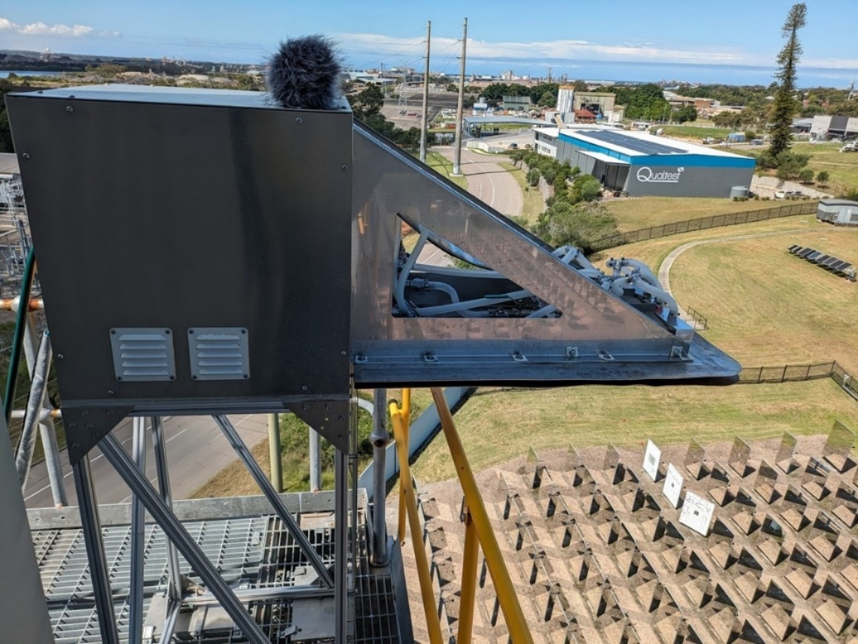The University of Adelaide’s Sparc Hydrogen project was funded to develop a system to produce ‘green hydrogen’ fuel. The University of Adelaide has partnered with Australian companies Sparc Technologies and Fortescue. This fuel is both a low-cost compared to electrolysis and a cleaner energy source as it only emits water vapour and leaves no residue in the air, unlike coal and oil. The project has successfully tested its second-generation prototype photocatalytic water splitting (PWS) reactor at the CSIRO Energy Centre in Newcastle, New South Wales. The PWS reactor uses sunlight to split water into hydrogen and oxygen, which in turn allows for the hydrogen to be captured and used as fuel.

*Side view of the second-generation prototype. Source: Lead entrepreneur Professor Greg Metha, Sparc Hydrogen.*

**The University of Queensland’s (UQ) Market-relevant Rechargeable Aluminium Battery Prototyping project: $151,960**

UQ has made significant steps toward its aim of developing a rechargeable aluminium battery prototype using graphene. This includes the scalable production of a high-capacity graphene battery in pouch cell prototypes which will compete with the predominant lithium-ion batteries in the global battery market (valued at over USD $300 billion by 2030). UQ has partnered with Brisbane-based Graphene Manufacturing Group to deliver this project. This project will help build expertise in the Australian battery industry to move further along the battery value chain.

In a recent validation exercise, the project constructed multiple cells, all of which testing greater than 1 Ampere-hour (Ah) (1000 mAh). Previous to this, the highest tested capacity was 500 mAh in 2023. This milestone underscores the scalability of the technology from coin cells to pouch cells and marks a pivotal advancement in the battery's development.

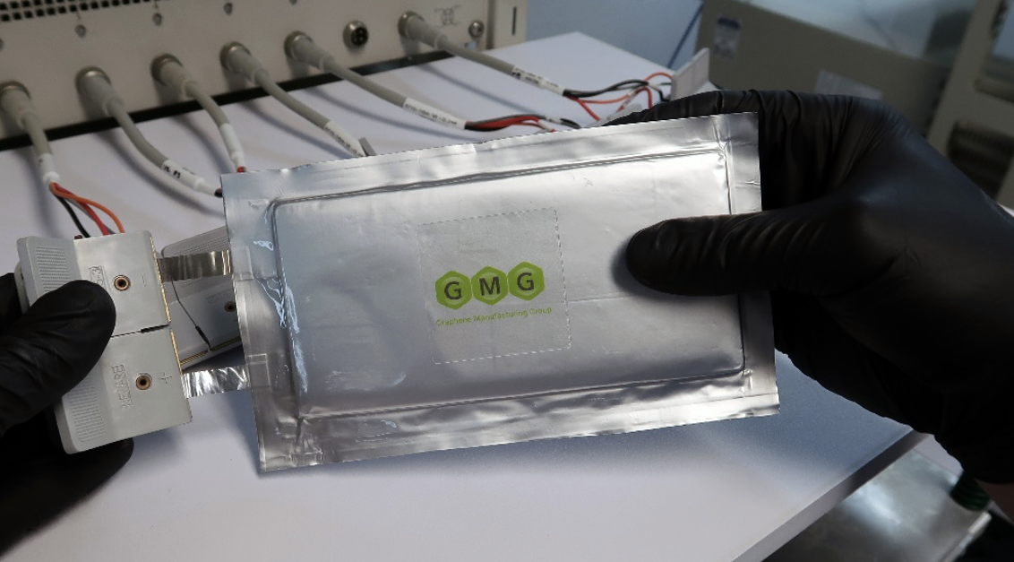*AIB 1Ah pouch cell.* *Source:* *Lead scientist Dr Xiaodan Huan, Graphene Manufacturing Group.*

#### 

#### Medical Science

**The University of Melbourne’s high resolution cortical recording for the prediction and prevention of epileptic seizures grant: $294,119**

More than 30% of the 60 million people worldwide living with epilepsy are drug resistant. This means that for many patients the anxiety associated with the unpredictability of seizures represents one of the primary burdens of the disease. Together with Carbon Cybernetics, the University of Melbourne is working to commercialise an implantable device that can monitor brain activity with high precision. Their aim is to predict and prevent epileptic seizures, which could also lead to a breakthrough in effectively treating depression and anxiety without the use of drugs.

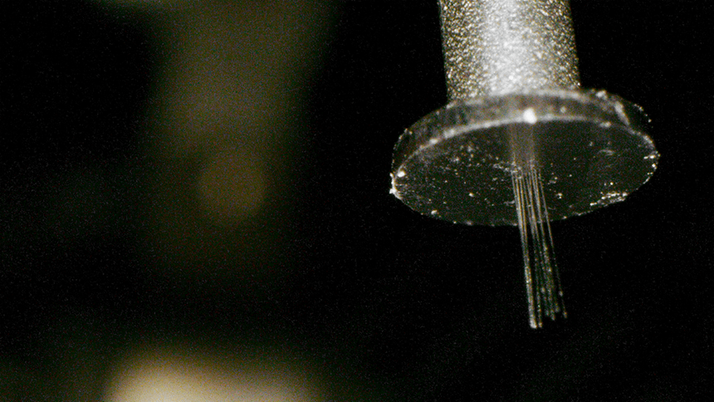This technology has the potential to transform the lives of individuals suffering from epilepsy by providing a drug-free treatment option. It's a significant advancement not only for Australian healthcare but also for global medical practices.

*Thin carbon fibres act as active electrodes. Source: Lead entrepreneur Professor Steven Prawer, University of Melbourne*

### Current state of AEA

The expected ongoing cadence of AEA rounds is 2 rounds each year of Ignite grants and 2 rounds of Innovate grants, with the Board reviewing the cadence when it develops its next investment plan.

AEA will fund projects that are aligned with the Government identified priority areas for the economy (outlined in the *National Reconstruction Fund Corporation (Priority Areas) Declaration 2023*). There will be a focus on supporting technologies that have real potential to address ‘real world’ problems with significant economic return to Australia.

Ignite grants support early-stage proof of concept projects at Technology Readiness Levels (TRL) 3-5, with grants of up to $500,000 over 12 months.

The Board will review the first round and provide advice on changes to program settings and requirements to ensure the AEA continues to deliver on its vision and aims.

## Related programs in Education portfolio

The Research Commercialisation Action Plan identified that reform was needed across the innovation system to address this innovative shortfall and improve the commercial returns of Australian university research.[11] Areas of focus are:

* putting national priorities at the core of Australian Government funded research
* investing in priority-driven schemes to ramp up commercialisation activity
* reforming existing university research funding to strengthen genuine collaboration with industry
* building a bedrock of key people across the sector who are skilled in university-industry collaboration.

To achieve these reforms, the department has established a suite of programs to help shift the Australian research landscape and increase research commercialisation.

### The Trailblazer Universities Program

AEA, the Trailblazer Universities Program and the Increase Workforce Mobility initiative are the core elements of the Government’s agenda to increase the commercial returns from the excellent research undertaken in Australia’s universities. The Trailblazer Universities Program is one of the priority-driven schemes to support select universities to boost R&D and drive culture change and commercialisation outcomes with industry partners.

In 2022, following a 2-stage competitive selection process assessed by an expert panel with significant experience and expertise across government, higher education, industry and innovation sectors, 6 universities were selected for the program:

1. **Curtin University - Resources Technology and Critical Minerals Trailblazer**, in partnership with the University of Queensland and James Cook University (priority sector: resources technology and critical minerals) ([rtcm-trailblazer.au)](https://rtcm-trailblazer.au/)
2. **Deakin University - Recycling and Clean Energy Commercialisation Hub (REACH)**, in partnership with University of Southern Queensland and Federation University (priority sector: recycling and clean energy) ([REACH | Deakin)](https://www.deakin.edu.au/research/research-partnerships/geelong-future-economy-precinct/reach)
3. **The University of Adelaide - Defence Trailblazer,** in partnership with the University of New South Wales (priority sector: defence) ([dtb.solutions)](https://dtb.solutions/)
4. **The University of Queensland - Food and Beverage Accelerator (FaBA**), in partnership with Queensland University of Technology and the University of Southern Queensland (priority sector: food and beverage) ([FaBA | Food and Beverage Accelerator)](https://faba.au/)
5. **University of New South Wales - Trailblazer for Recycling and Clean Energy (TRaCE),** in partnership with University of Newcastle (priority sector: recycling and clean energy) ([Trailblazer | Recycling & Clean Energy Trailblazer for Recycling and Clean Energy (TRaCE))](https://trace.org.au/)
6. **University of Southern Queensland - Innovative Launch, Automation, Novel Materials, Communications and Hypersonics Hub (iLAuNCH)**, is in partnership with the University of South Australia and the Australian National University (priority sector: space) ([iLAuNCH – Home)](https://ilaunch.space/).

All Trailblazer universities have a regional footprint, with one regionally headquartered university (University of Southern Queensland) and a further 2 universities funded to deliver regional impact (Curtin University and Deakin University). Nearly 30% of Australian universities are involved in the Trailblazer Universities Program.

The Trailblazer Universities program provides $370.3 million over four years from 2022-23 to 2025-‑26 to drive commercialisation outcomes and boost university collaboration with industry. Each Trailblazer university receives $50 million with matched funding by the lead university and their industry partners.

Between them, the Trailblazer universities anticipate attracting around $648 million in co-investment from industry. In total, Trailblazer universities are expected to deliver approximately $1.3 billion in investment from universities, partners and the Commonwealth Government, including cash and in-kind contributions. The following table illustrates the university projects and their industry partnership targets:

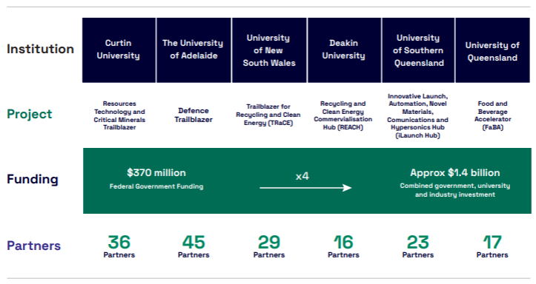Figure 1. Trailblazer university projects industry partnership targets

As at 31 December 2023, Trailblazer universities have partnerships with 152 industry partners contributing approximately $500 million in co-contributions to the projects. All Trailblazers have established joint commercialisation projects producing world-class results. Achievements so far include UniSQ’s iLAuNCH project has collaborated with the National Aeronautics and Space Administration (NASA) on the NASA-led HORIS observation project, conducting re-entry observations on the OSIRIS-REx capsule. The iLAuNCH Trailblazer also funded a project between industry partner Space Machines and the Australian National University (ANU). Space Machines Company is building the Optimus Platform, the largest single Australian-built commercial spacecraft, that will deliver transport and service capabilities in orbit.

The University of Adelaide’s Defence Trailblazer for Concept to Sovereign Capability has partnered with CAE Australia to investigate AI Assisted Cognitive Lead Assessment for Mission Aviators. The objective is to accelerate the implementation of training technologies to enhance the mission preparedness, safety, and performance of their personnel. The university has also established a Seed Funding Program for partners to create deployable prototypes of technologies in Defence’s priority capability areas.

Curtin’s Resources Technology and Critical Minerals Trailblazer has established its Venture Studio to develop new technologies to facilitate commercial development of new product and service opportunities to support the resources sector. Three pilot projects are currently underway. Australia’s first full Venture Studio will match early-stage product and service assets with people, infrastructure, training support and seed funds to fast-track to market or, as appropriate, fail fast. Deakin’s REACH Trailblazer is working with Clean Energy Resources to covert old tyres into hydrogen, electricity and other reusable resources without harming the environment. The REACH program has 10 Hub partners, currently progressing 9 commercial projects of varying size and scale, each of which are being delivered in regional areas of Victoria.

In addition to building research commercialisation capacity in key areas of strength and priority for Australia, the Trailblazers and their partners are working to drive cultural change within their institutions and across the sector more generally. A key aim is for Trailblazers to function as exemplars of innovative arrangements and best practice to support industry and end-user engagement in research. Trailblazer universities have all established governance arrangements that include industry representatives and end-users to help drive this culture change and are adopting innovative intellectual property management, research incentives and skills practices that promote university-industry collaboration, and reward academics working with industry. For example, to support early career academics, Trailblazers have established scholarships and bursaries for PhD and post-doctoral students to work with industry, working with the Increase Workforce Mobility Initiative.

Trailblazers are also focused on creating regional impact. An example of the success of this strategy is the University of New South Wales (UNSW). UNSW has established 2 regionally based projects, one in Muswellbrook NSW to support biotechnology start-ups and another partnership in Taree,

### Workforce initiatives

The Increase Workforce Mobility Initiative (the Initiative) is a $296 million investment to build an industry focused research workforce. The initiative comprises 6 industry PhD and research fellowship programs that span the research career pathway. It will support an additional 1,800 Industry PhDs and 800 Fellows over 10 years from 2023 to work across industry and academia and solve industry problems. This initiative feeds into Trailblazer activities to upskill students, develop academic pathways that lead to industry partnerships and opportunities for career mobility. Students will gain valuable experience and networks that will serve them well in future translation endeavours, including through the AEA.

The department, the Australian Research Council (ARC) and CSIRO are working together to deliver this initiative:

* The department administers the National Industry PhD Program, which supports PhD candidates to undertake research projects focused on real world problems in an industry setting and equips them with the knowledge and skills to better translate university research into commercial outcomes
* The ARC’s Early Career, Mid-Career, and Industry Laureate Fellowships promote partnerships between researchers, universities and Australian industry, and create pathways to support academic researchers in establishing careers in industry and industry-based researchers to work in university settings
* CSIRO’s Industry PhD program brings together industry partners, a university, and Australia’s leading science agency (CSIRO), to co-develop a 4-year industry-focused PhD project in which students gain unique skills and focus on impact-driven research.

All these streams aim to develop the industry-university collaboration skills of researchers, support them to achieve outcomes that can be translated and/or commercialised and drive greater collaboration between Australia’s universities and industry.

The National Industry PhD Program (the PhD program) is a key initiative within the suite of research commercialisation programs currently being implemented by the department, focused on assisting researchers with projects at TRLs 1-2.

The PhD program consists of 2 distinctive streams:

1. **Industry Linked PhDs**: for highly capable PhD candidates to undertake research projects co-designed by university and industry with opportunities to be embedded in an industry setting and participate in a 12-week training program.
2. **Industry Researcher PhDs**: for highly capable industry professionals, who are supported by their employers to undertake PhD projects in partnership with a university, while retaining industry employment and salary benefits.

The objectives of the PhD program are to:

* develop talented PhD candidates into researchers who can work in both industry and academic settings
* support industry professionals to develop expert research skills and support the next generation of industry researchers and leaders
* contribute to and strengthen industry-focused innovation and development through greater university-industry collaboration
* support PhD research projects co-designed between university and industry, aligning with Australian Government priorities, particularly the Government identified priority areas for the economy, outlined in the *National Reconstruction Fund (NRF) Corporation (Priority Areas) Declaration 2023* (Fig. 2).

Figure 1. Trailblazer university projects industry partnership targets

To 30 June 2024, the number of Industry PhDs/Fellowships awarded is approximately 348, with another 150 anticipated to be announced early into the 2024-25 FY (Fig. 3).

Around 44% of candidates who have commenced to date are women. As part of future rounds, the department will continue to promote the program to under-represented cohorts with a view to increasing equity outcomes.

The projects below are examples of opportunities to draw on research for real-world impact:

* Curtin University's investigation into Parkinson's Disease to better understand and potentially mitigate this debilitating condition
* Macquarie University's initiative to develop portable sensors that will detect pregnant cattle and revolutionise cattle management
* The University of Adelaide's pursuit of a vaccine to prevent ear infections in children and lung infections in adults
* The University of Western Australia's examination of Indigenous equity in energy transitions.

Figure 3. Number of funded Industry PhDs/Fellowships

The participation of different industry partners, including a reasonable proportion of small and medium-sized enterprises (Fig. 4) and for-profit organisations (Fig. 5), is encouraging and will build capability, economic resilience and competitiveness.

**Figure 4. Comparative overview: industry partner participation by sector type.**

|  |  |  |  |  |  |
| --- | --- | --- | --- | --- | --- |
| **Round** | **Partnership status** | | **Size of organisation** | | |
|  | **Existing** | **New** | **Small** | **Medium** | **Large** |
| Round 1 | 62 | 24 | 22 | 27 | 37 |
| Round 2 | 71 | 57 | 36 | 46 | 46 |
| Round 3 | 94 | 50 | 50 | 42 | 52 |
| **Totals** | **227** | **131** | **108** | **115** | **135** |

**Figure 5. Comparison of submitted applications across 3 rounds: for-profit, government, and non‑profit sectors**

### National Collaborative Research Infrastructure Strategy (NCRIS)

Another pillar of the Government’s investment in supporting research innovation and partnerships is through the National Collaborative Research Infrastructure Strategy (NCRIS). The Government invested a further $650 million to support national research infrastructure through NCRIS in 2023.

The Government has invested $4 billion over 12 years (from 2018 to 2029) to support important pieces of national research infrastructure. National research infrastructure provides access to researchers and industry, and supports the development of the research workforce. National research infrastructure underpins our national research effort and is essential to support breakthrough research discoveries, adapting to new technologies, and addressing global challenges.

This long-term, strategic approach to national research infrastructure provides strong foundations for Australia’s research sector and a national network of facilities that respond to Australia’s research infrastructure needs.

NCRIS is a national network of 26 projects that:

* operate through a network of approximately 200 delivery partnerships with Australia’s universities and publicly funded research agencies
* harness the combined effort of approximately 1,500 experts
* support the research of an estimated 90,000 Australian and 10,000 international researchers each year, leading to an estimated 9,000 publications
* help generate an additional $1.40 for each $1.00 of NCRIS funding.

## 

## Conclusion

With its research commercialisation strategy and investment plan, the Board has laid the foundations to shift the dial to bring about culture change in Australia’s universities and deliver greater rates of research translation and commercialisation in Australia.

The AEA, the Trailblazer Universities program, the Increase Workforce Mobility Initiative and NCRIS will improve the rate of human and physical collaboration, by backing Australian ideas and increasing investment in the people, businesses, and communities that drive our nation’s economy.

The coming year will be an exciting one, with the opening of AEA Ignite and Innovate funding rounds. The Board, supported by priority managers and the Department of Education, will continue to engage with research, industry and innovation stakeholders to increase participation in the AEA and create more opportunities for industry co-investment and collaboration across the research system.

## Appendices

### Appendix A: Board member’s terms of appointment

|  |  |  |  |
| --- | --- | --- | --- |
| **Name** | **Role** | **Start date** | **End date** |
| Mr Jeff Connolly | Chair | 3 July 2024 | 2 July 2029 |
| Ms Julia Spicer OAM | Deputy Chair | 3 July 2024 | 2 July 2029 |
| Dr Angeline Achariya GAICD | Member | 3 July 2024 | 2 July 2029 |
| Prof Mark Hutchinson | Member | 3 July 2024 | 2 July 2027 |
| Dr Paul Kelly | Member | 3 July 2024 | 2 July 2027 |
| Dr Virginia Marshall | Member | 3 July 2024 | 2 July 2027 |
| Ms Catherine Roberts AO CSC | Member | 3 July 2024 | 2 July 2029 |
| Ms Lauren Stafford | Member | 3 July 2024 | 2 July 2027 |

1. [www.nrf.gov.au](https://www.nrf.gov.au/)
2. Clarivate, Web of Science Documents, Clarivate Incites Website, 2024, accessed 2024.
3. The World Bank, Population Indicators, The World Bank, 2024, [Population, total - Australia, World | Data (worldbank.org),](https://data.worldbank.org/indicator/SP.POP.TOTL?locations=AU-1W) accessed 2024.
4. Australian Research Council (ARC), State of Australian University Research 2018–19: ERA National Report, ARC, Australian Government, 2019, accessed 2024. Calculated as the sum of Rating 3, Rating 4 and Rating 5 2-digit Units of Evaluation (UoEs).
5. OECD, Business innovation statistics and indicators, OECD 2024, [Business innovation statistics and indicators - OECD](https://www.oecd.org/sti/inno/inno-stats.htm), accessed 2024.
6. The Atlas of Economic Complexity, atlas.cid.harvard.edu, accessed 2024.
7. DISER, Innovation Systems Monitor, DISER, Australian Government, 2021, accessed 2024.
8. World Economic Forum (WEF), Global Competitiveness Report 2019, WEF website, 2019, accessed 2024.
9. [www.industry.gov.au/publications/science-research-and-innovation-sri-budget-tables-2023-24](https://www.industry.gov.au/publications/science-research-and-innovation-sri-budget-tables-2023-24)
10. [www.aea.gov.au](http://www.aea.gov.au)
11. [www.education.gov.au/research-translation-and-commercialisation-agenda/resources/research-commercialisation-action-plan](https://www.education.gov.au/research-translation-and-commercialisation-agenda/resources/research-commercialisation-action-plan)